**Sindh:**

Keenjhar Lake

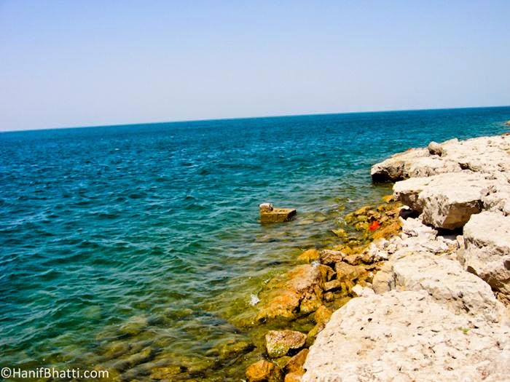

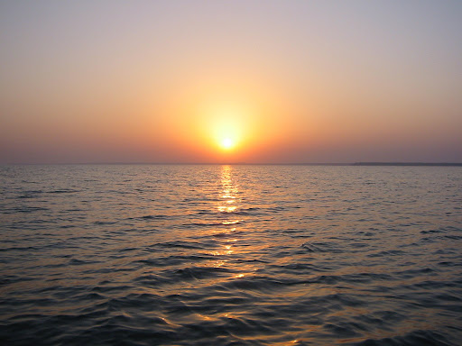

**Keenjhar Lake** is in Thatta District, Pakistan. It is 122km from Karachi and 18km from the town of Thatta. It is the second largest fresh water lake in Pakistan. It is an important source of drinking water for Thatta District and Karachi city. Keenjhar Lake has been declared a ramsar site and a wildlife sanctuary. It provides a favorable habitat of winter migratory birds like ducks, geese, flamingos, cormorants, waders, herons, egrets, ibises, terns, coots and gulls. It has been observed as a breeding area of the black-crowned night heron, the cotton pygmy goose, purple swamphen, and pheasant-tailed jacana.